Water District
Notice of Public Hearing on Tax Rate
The Cape Royale Utility District will hold a public hearing on a proposed tax rate for the tax year 2023 on September 21,2023 at 3pm @1330 Cape Royale Dr, Coldspring Tx 77331. Your individual taxes may increase at a greater or lesser rate, or even decrease, depending on the tax rate that is adopted and on the change in the taxable value of your property in relation to the change in taxable value of all other property. The change in the taxable value of your property in relation to the change in the taxable value of all other property determines the distribution of the tax burden among all property owners. Visit Texas.gov/PropertyTaxes to find a link to your local property tax database on which you can easily access information regarding your property taxes, including information about proposed tax rates and scheduled public hearings of each entity that taxes your property.

FOR the proposal: Dale Toronjo, Richard Masterson, Alex Onjanow, Douglas Pulgini, Lynn Watkins
AGAINST the proposal: N/A .
PRESENT and not voting: N/A .
ABSENT: N/A .
The following table compares taxes on an average residence homestead in this taxing unit last year to taxes proposed on the average residence homestead this year.
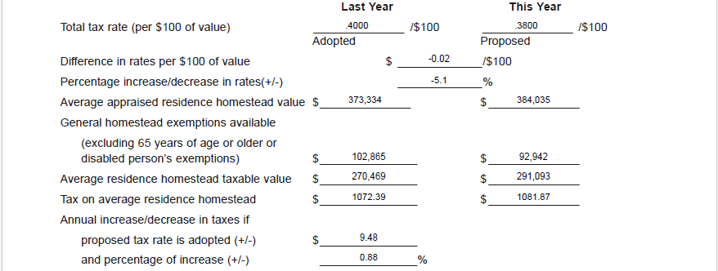

If the proposed combined debt service, operation and maintenance, and contract tax rate requires or authorizes an election to approve or reduce the tax rate the N/A proposes to use the tax increase for the purpose of N/A .

If the district is a district described by Section 49.23602:
NOTICE OF VOTE ON TAX RATE
If the district adopts a combined debt service, operation and maintenance and contract tax rate that would
result in the taxes on the average residence homestead increasing by more than 3.5 percent, an election
must be held to determine whether to approve the operation and maintenance tax rate under Section
49.23602, Water Code. An election is not required if the adopted tax rate is less than or equal to the
voter-approval tax rate.

The 86th Texas Legislature modified the manner in which the voter-approval tax rate is calculated
to limit the rate of growth of property taxes in the state.

